**DAILY ONLINE ACTIVITIES SUMMARY**

|  |  |  |  |  |  |  |  |  |
| --- | --- | --- | --- | --- | --- | --- | --- | --- |
| **Date:** | **24/05/2020** | | | | | **Name:** | **Anusha** | |
| **Sem & Sec** | **8th A** | | | | | **USN:** | **4AL16CS014** | |
| **Online Test Summary** | | | | | | | | |
| **Subject** | | **No test** | | | | | | |
| **Max. Marks** | | **-** | | **Score** | | | **-** | |
| **Certification Course Summary** | | | | | | | | |
| **Course** | Introduction to Hadoop | | | | | | | |
| **Certificate Provider** | | | **Great learning** | | **Duration** | | | **Mins 19** |
| **Coding Challenges** | | | | | | | | |
| **Problem Statement: Rotation of Array** | | | | | | | | |
| **Status: COMPLETED** | | | | | | | | |
| **Uploaded the report in Github** | | | | | **YES** | | | |
| **If yes Repository name** | | | | | **anushasuvarna-014** | | | |
| **Uploaded the report in slack** | | | | | **YES** | | | |

Certification Course Details:

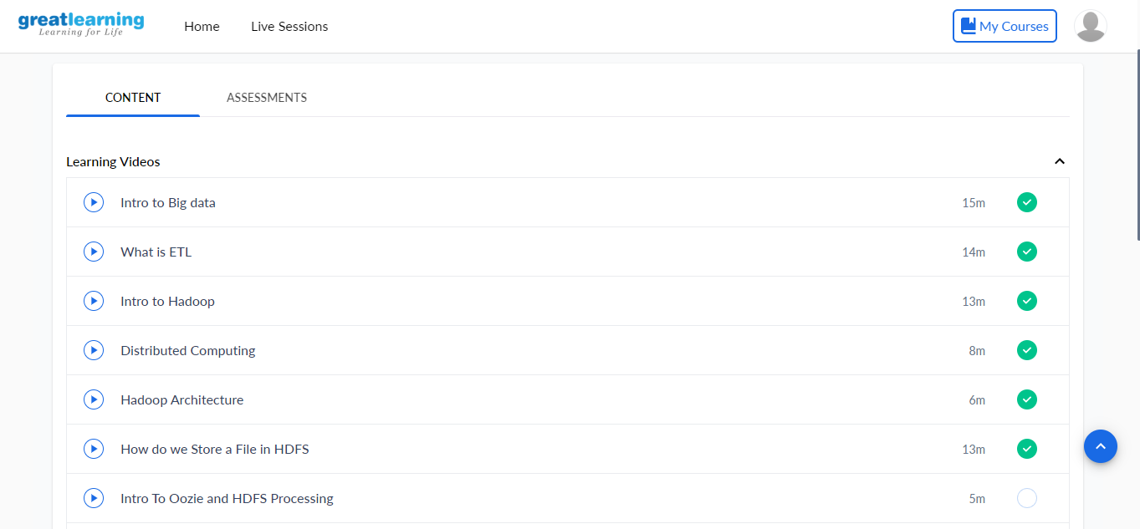

Coding Challenges Details:

array = list(map(int, input("Enter array : ").split()))

print("Missing Number :", sum(list(range(max(array)+1))) - sum(array))